Displaying Data from multiple tables using Joins
- Write a query for the HR department to produce the addresses of all the departments. Use the EMP and DEPT tables. Show the EMPNO, ENAME, SAL, DNAME and LOC in the output. Use a NATURAL JOIN to produce the results.
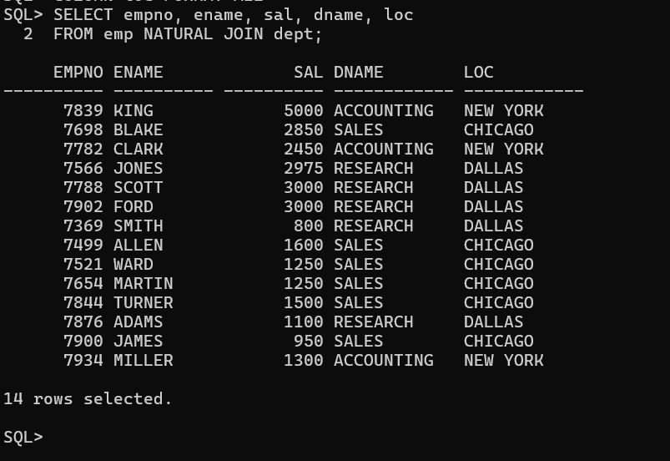

- The HR department needs a report of all employees. Write a query to display the JOB, MGR, SAL, COMM, DNAME of employees whose JOB is SALESMAN
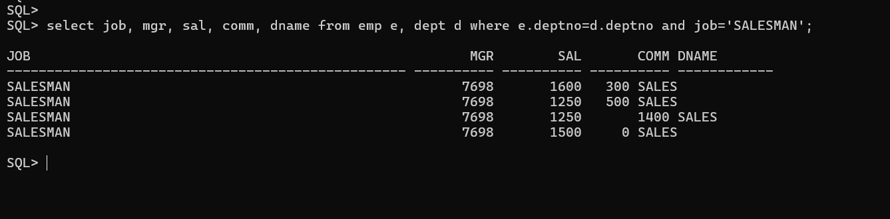

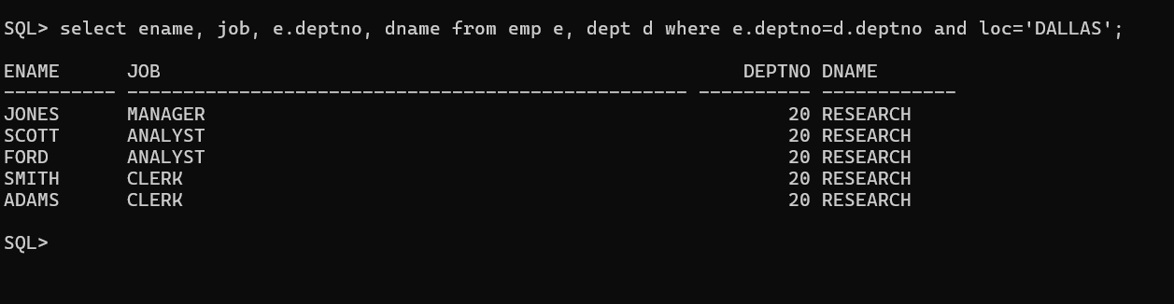
- The HR department needs a report of employees in LOC DALLAS. Display the ENAME, JOB, DEPTNO, and DNAME for all employees who work in DALLAS.

- Create a report to display employees' name and employee number along with their manager's name and manager number. Label the columns Employee, Emp#, Manager, and Mgr#, respectively.

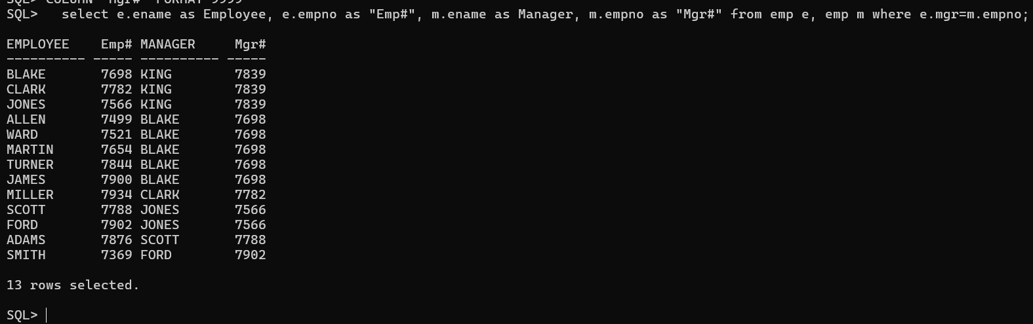
- Modify the previous query to display all employees including King, who has no manager. Order the results by the employee number.
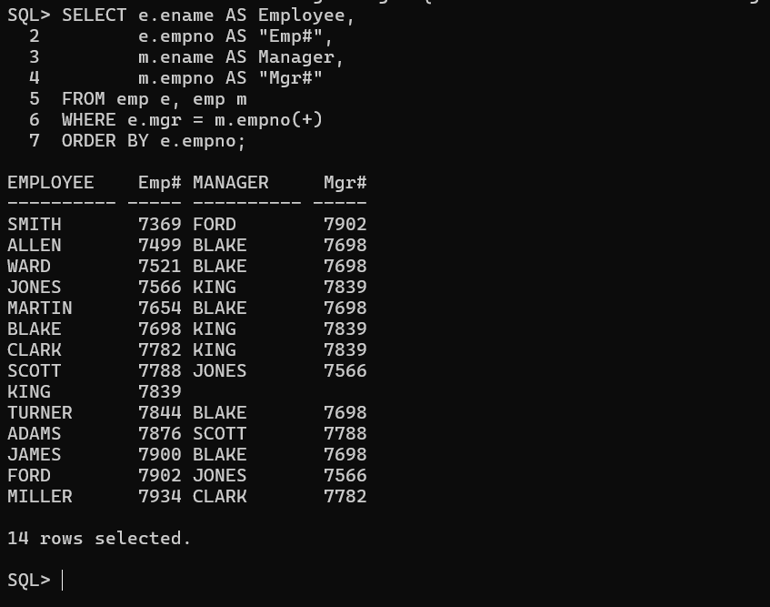

- The HR department needs a report on job grades and salaries. To familiarize yourself with the SALGRADE table, first show the structure of the SALGRADE table. Then create a query that displays the name, job, department name, salary, and grade for all employees.
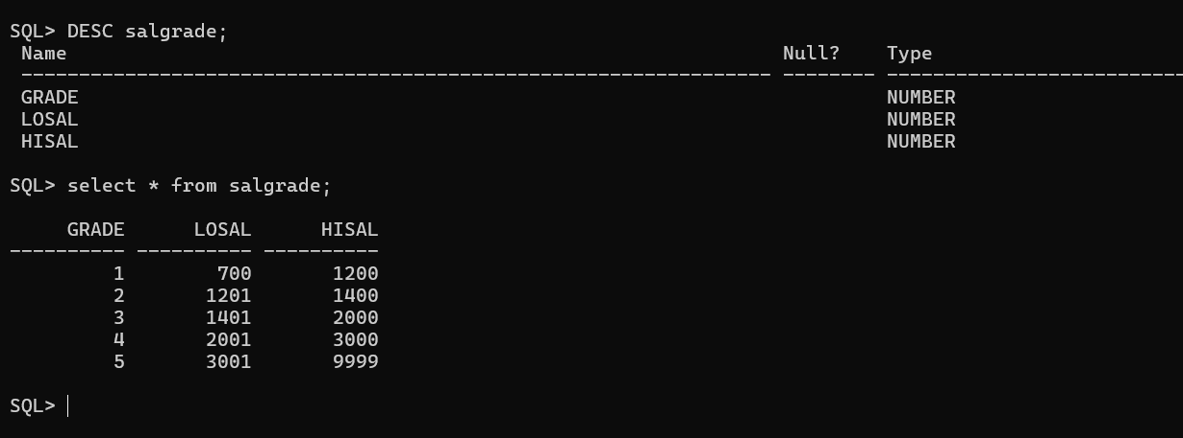
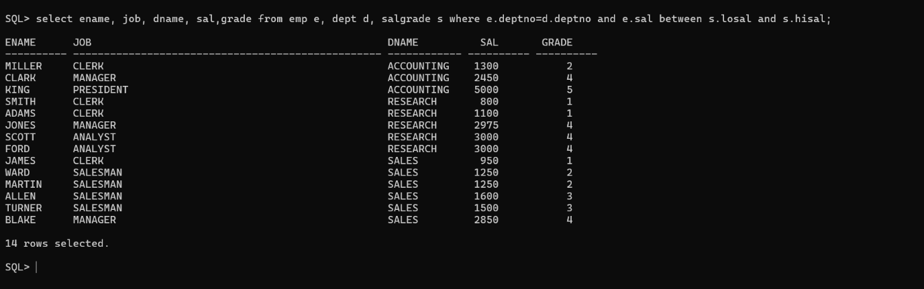

- Display the ENAME, DNAME of all the employees. Also display those department name which do not have any employees working.
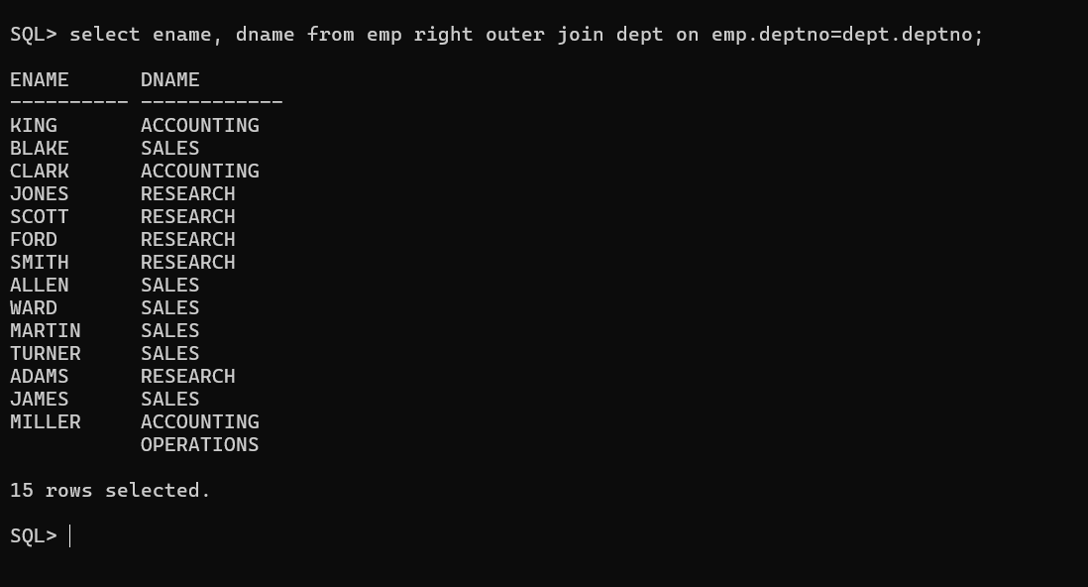

- The HR department needs to find the names and hire dates for all employees who were hired before their managers, along with their managers' names and hire dates.
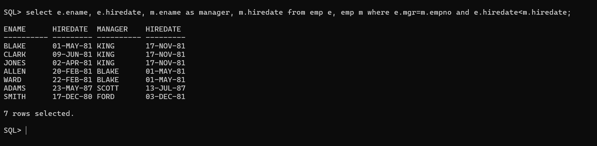
- Display the EMPNO, ENAME, DNAME, LOC of those employees who are working as CLERK. Use the USING clause.
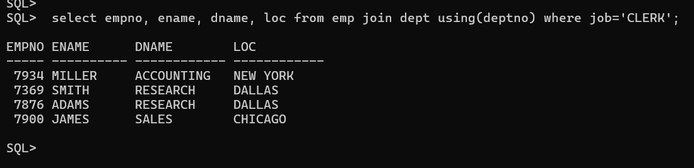
10.Display the ENAME, SAL, MGR, DNAME of employees whose salary is more than 2000. Use the ON clause.
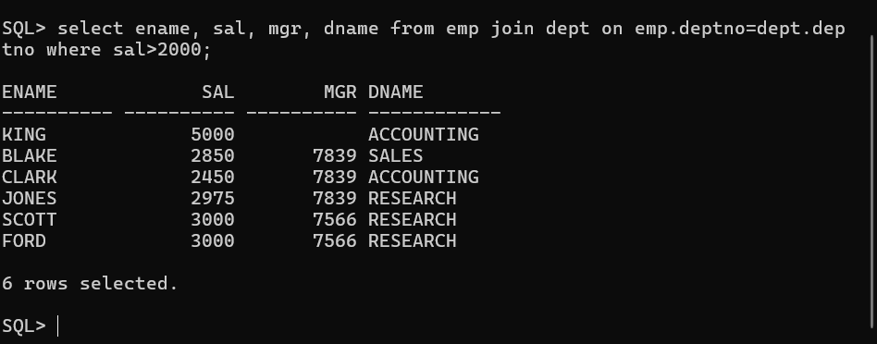
11.Display the EMPNO, ENAME, JOB, DEPTNO, DNAME, LOC of employees. Use LEFT OUTER JOIN. 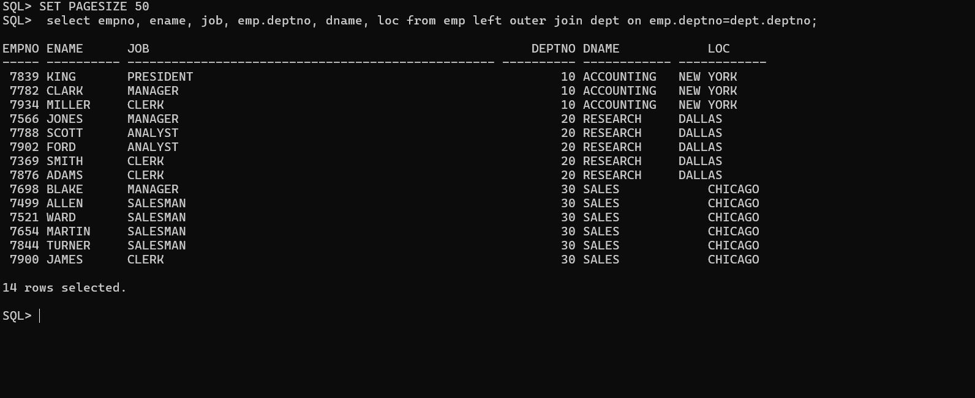
12.Display the ENAME, DNAME of employees. Use RIGHT OUTER JOIN.
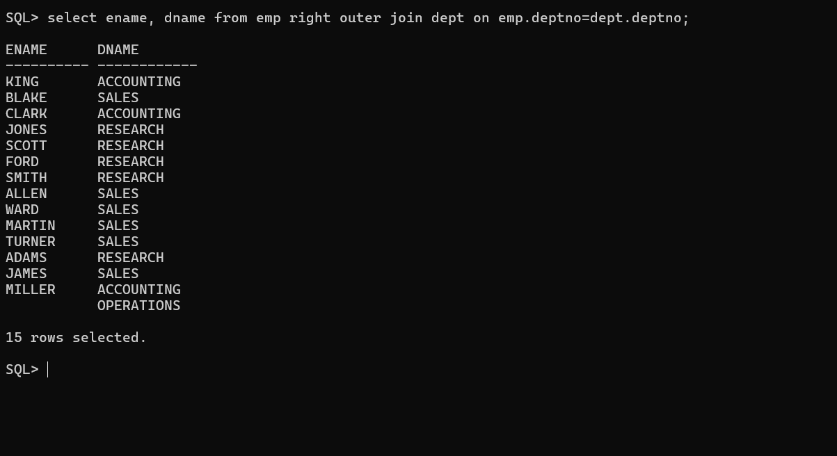
13.Display the EMPNO, DNAME, LOC of employees. Use FULL OUTER JOIN. 